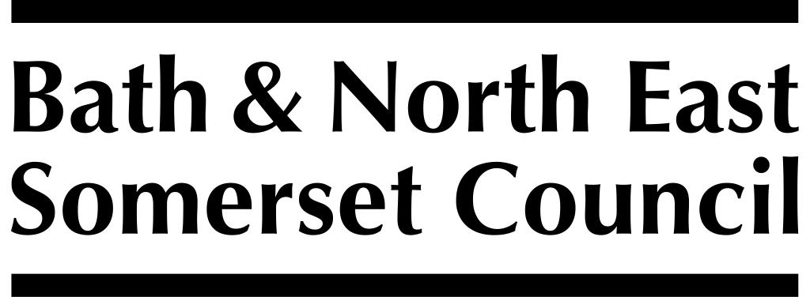

RISK ASSESSMENT
Fashion Museum galleries and Assembly Rooms, Bath.

Date: 31/09/19

 | HAZARD | CONTROLS in PLACE | RISK RATING | ADDITIONAL CONTROLS needed
1 | Doors to ARs  [fall, injury] | - Individuals supervised by parents and teachers on entry and departure | low
2 | Stairs to lavatories  [slip, trip or fall] | - Handrails  - Clear ‘nosing’ to stair treads | low | - Monitor condition of stair carpet; take remedial action if it becomes a risk
3 | Hot water in cloakrooms | - Notices warning ‘Hot water’ | low | - Mixer taps installed
4 | Stairs to museum  [slip, trip or fall] | - Handrails  - Clear ‘nosing’ to stair treads  - Heritage staff warn about low light levels  - Acoustiguide script warns about low light levels | low
5 | Disorientation on the site  [lost & upset children] | - Heritage staff supervise the group  - Installed more orientation signs around building | low
6 | Noise on the site  [upset visitors] | - Heritage staff supervise | low
7 | Practical workshops  [injury] | - Heritage staff supervise workshops  - Heritage staff ensure sufficient staff / children ratio  - Use of non-toxic materials  - Restricted use of sharp instruments | low
8 | Emergency evacuation  [lost & upset children, slips, trips & falls, injury] | - Heritage staff supervise  - Heritage staff trained in evacuation procedures  - Evacuation procedures posted clearly throughout building | low
9 | Emergency  [accident or injury to child ] | - Heritage staff trained first aider on site at all times
10 | Heavy audioguides  [injury] | - Heritage staff request audioguides worn on strap around neck | low
11 | ‘Invisible’ glass cases  [injury] | - Heritage staff brief groups on possibility of walking into large glass cases | low
12 | Users with limited access, eg wheelchair users | - Heritage staff accompany users in lift | low

